**Zhumagali Kanat IT2-2003**

**Lab6. Creating Triggers**

1. Create at least three triggers with the functionality according to the database subject area.
2. Demonstrate the results of triggers functioning.

1.

create or replace trigger movie_aud_trigger

after delete or update on movie

for each row

begin

if deleting then

insert into movie_audit(pr_movie_id, pr_film_name, pr_duration, pr_year_of_release, pr_rating_imbdb)

values (:old.movie_id, :old.film_name, :old.duration, :old.year_of_release, :old.rating_imbdb);

dbms_output.put_line('Deleted values saved in movie_audit table');

elsif updating then

insert into movie_audit(pr_movie_id, pr_film_name, pr_duration, pr_year_of_release, pr_rating_imbdb)

values(:old.movie_id, :old.film_name, :old.duration, :old.year_of_release, :old.rating_imbdb);

dbms_output.put_line('Updated values saved in movie_audit table');

end if;

end;

select * from movie

select * from movie_audit

delete from movie where movie_id = 300

insert into movie(movie_id, film_name, duration, year_of_release, rating_imbdb)

values(300, 'the thing', '2:22', 1987, '9/10')

create table movie_audit(

pr_movie_id number,

pr_film_name varchar2(40),

pr_duration varchar2(20),

pr_year_of_release number,

pr_rating_imbdb varchar2(10)

)

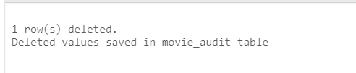

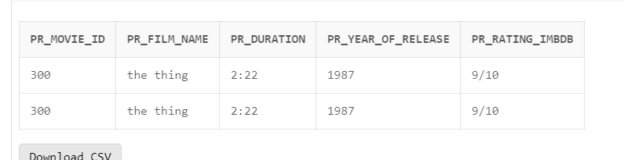

update movie set duration = '2:10' where movie_id = 10

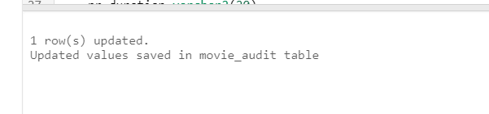

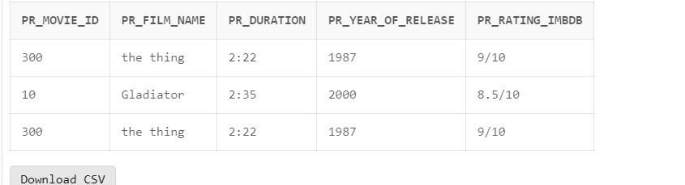

2.

create or replace trigger check_duration_rating_format

before insert or update on movie

for each row

begin

if not regexp_like(:new.duration, '^\d+:\d+$') is null then

raise_application_error(-20001, 'Invalid duration format. Please use the format Hourse:Minute');

end if;

if not regexp_like(:new.rating_imbdb, '^[1-9]/10$|^10/10$') then

RAISE_APPLICATION_ERROR(-20001, 'Invalid rating_imbdb format. Please use the format X/10, where X is between 1 and 10.');

end if;

end;

insert into movie(movie_id, film_name, duration, year_of_release, rating_imbdb)

values(304, 'the thing', '2 hours 22 minutes', 1987, '10/10');

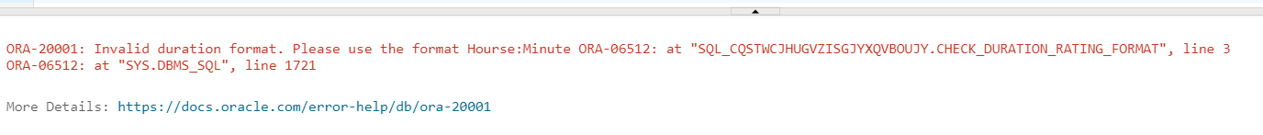

INSERT INTO movie(movie_id, film_name, duration, year_of_release, rating_imbdb)

VALUES(305, 'the thing', '2:22', 1987, '12/10');

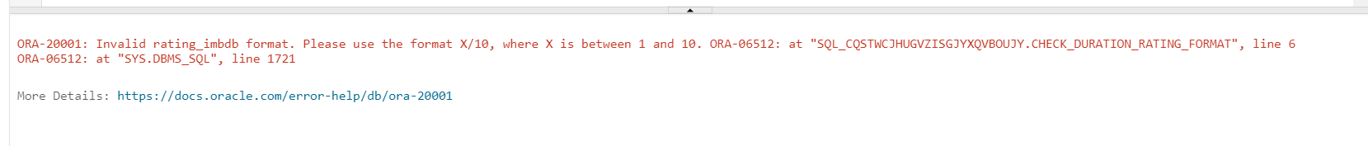

3.

alter table movie

add modification_date TIMESTAMP;

create or replace trigger modification_trigger

before update on movie

for each row

begin

:new.modification_date := TO_CHAR(SYSDATE, 'DD-MON-YYYY HH24:MI:SS');

dbms_output.put_line('Modification date saved');

end;

update movie set film_name = 'The Thing' where movie_id = '300';

select * from movie

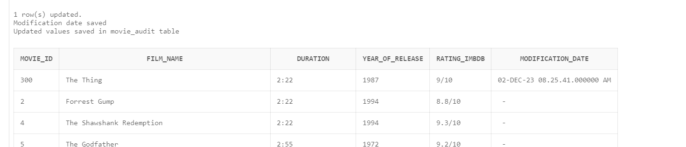

Questions:

1. What are triggers for?
2. What are the types of triggers depending on the execution time?
3. What are the types of triggers depending on triggering events?
4. Describe statement level triggers with examples.
5. Describe row level triggers with examples.
6. What is the sequence of execution of statement and row triggers?
7. Describe **new** and **old** qualifiers, and their structure.
8. What is the section WHEN for?
9. How a trigger is created.
10. How the triggering events can be grouped?
11. When INSTEAD OF triggers are used?
12. How to create a disabled trigger?
13. How to enable or disable a trigger?
14. What is a mutating table?
15. What is a compound trigger?
16. In which sequence the sections in a compound trigger must be defined?
17. How to create a compound trigger?
18. For which database objects can a compound trigger be created?